MACH4METAL

metalworking machinery
Transito 21,
6909 DA BABBERICH, Netherlands
Tel. + 31 (0)316 – 247123
Fax. + 31 (0)316 - 247956
info@mach4metal.com
www.mach4metal.com

Bank No : 66.52.13.883
IBAN : NL33 INGB 0665 2138 83
BIC : INGBNL2A

SABI Bandsaw PBR 550 x 1000
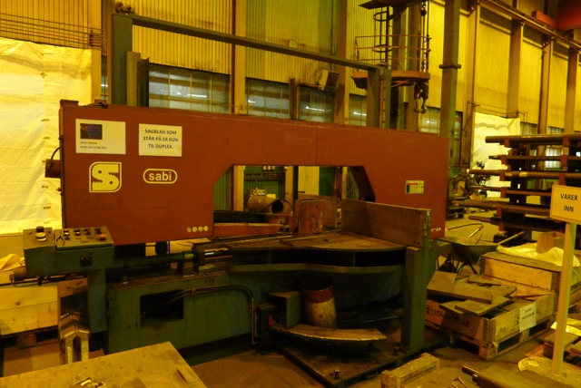

- Make : SABI - Spain
- Type : PBR 550 / 1000
- Age : 2002
- Mach.No. : L 76777

- Sawing capacity
- Round Ø : 550
- Flatt 0˚ : 1.000 x 520
- Flatt - 45˚ : 650 x 520
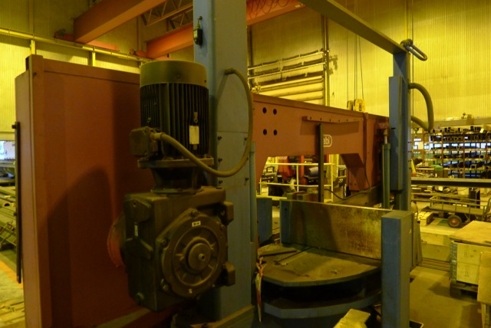
- Flatt - 60˚ : 425 x 520

- Cutting speed : 15 – 105 M/Min
- Blade size : 8.400 x 54 x 1.3
- Power : 400 V / 7.5 kW

- Dimensions
- Length : 4.570
- Width : 1.940
- Height : 2.570
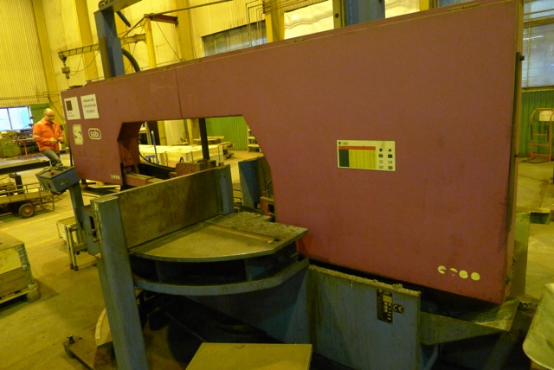
- Weight : 6.000

- Semi automatic hydraulic Bandsaw
- Hydraulic blade tension
- 5˚ inclines blade
- New Euro 78.000
- Head guiding with bearings and linear
guides

Please Note: The above information has been obtained to the best of our ability and belief from, and from the manufacturers where possible. It is given in good faith, but its accuracy can not be guaranteed. Accordingly, it will not form a representation or constitute contractual terms. We advise you to check any vital details!

